

**Lab Report**

**Course Title: Object Oriented Programming II Lab**

**Course Code: CSE222**

**Experiment No: 02**

**Experiment Name: Problem Solving**

**Submitted To: Ms. Umme Ayman**

Department of CSE

Daffodil International University

**Submitted By:**

Name: Tamanna Akter

ID: 221-15-5298

Section: 61_M

Department of CSE

Daffodil International University

|  |
| --- |
| Submission Date: 19/02/2024 |

Problem set -1

Problem -1:

Problem -01: Suppose, you are working as a python programmer in a Software company.You are asked to create a python program which will take a String as an Input and rotate some of it’s characters to make a secure password.

Now, ➔ You should take input string of ‘m’ size without whitespace. ➔ Take ‘n’ as the numbers of characters to rotate the string . ➔ Where n<=m Sample Input: Size of String m= 9 Input String:ummeAyman Number of characters to rotate:05

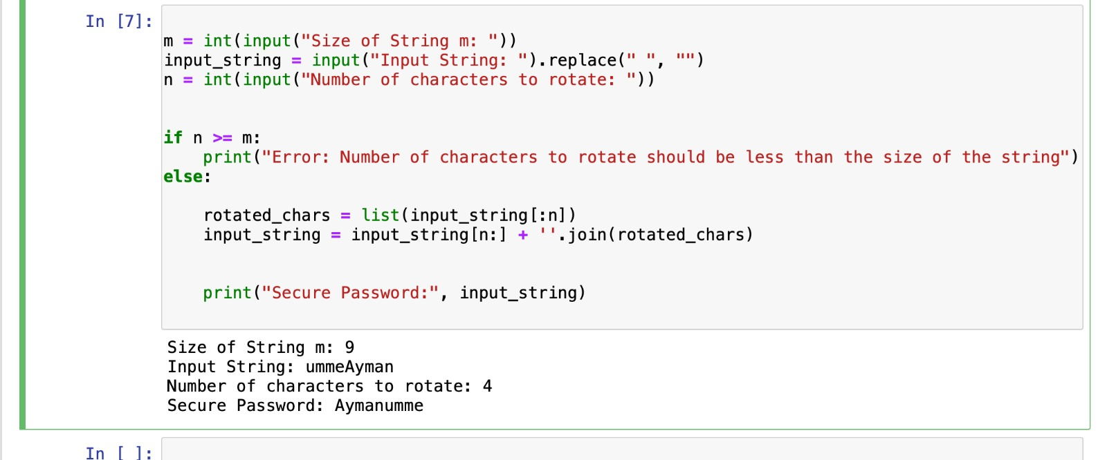

Problem – 2:

Problem -02: Suppose, you are a security engineer of an IT organization.You are asked to develop a system which converts the company’s Employees name into a numerical value to ensure Employees anonymity in terms of security enhancement.Now, 1. You take a list of employee name. 2. Find out the ASCII values of all Characters of each employee name. 3. Then, add the all ASCII values of each name as well as store that sum value in another list. Sample Input: EmployeeName:[“Umme” ,”Eity”, “Esrat”] Sample Output: NumericalValues=[207,135,245

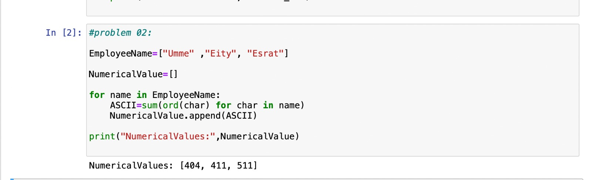

Problem set -2

Problem-1

roblem 1: Write a Python function that takes a list and returns a new list with unique elements from the first list.

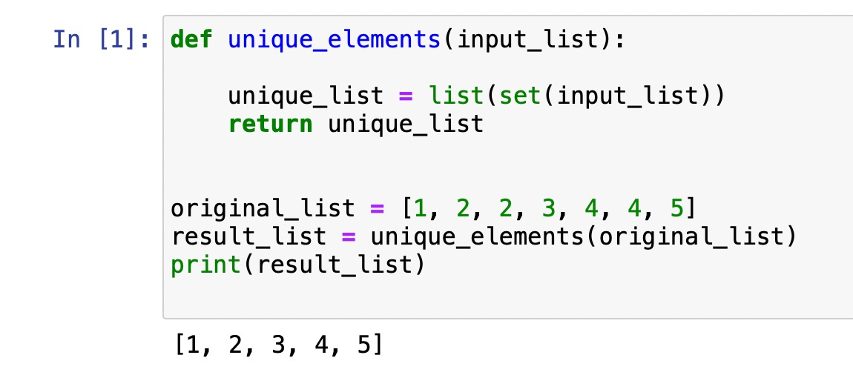

Problem -2:

Problem 2: Write a Python program to reverse print a list using recursion.

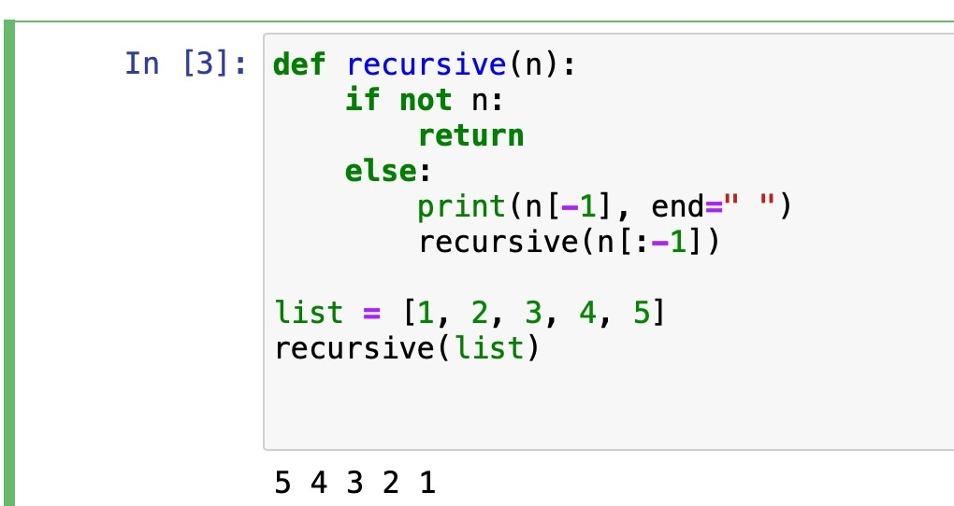

Problem -3:

Problem 3: Write a function that inputs a number and prints the multiplication table of that number

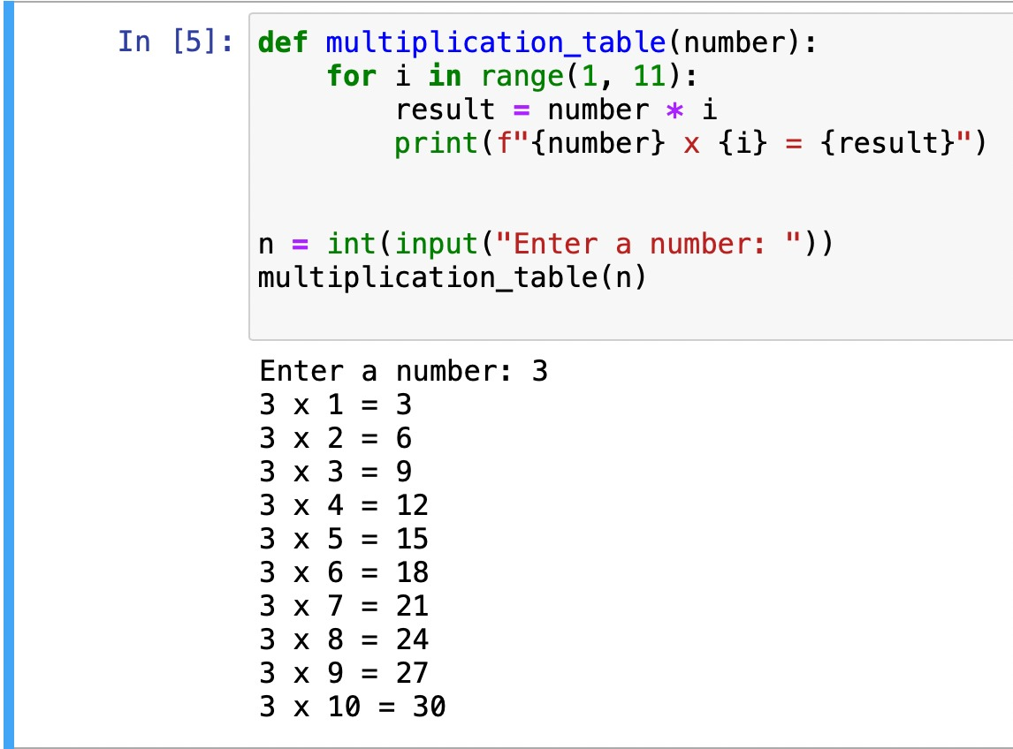

Problem -4:

Problem 4: Write a program to reverse an integer number using for loop or while loop. Example : 1435 Result : 5341

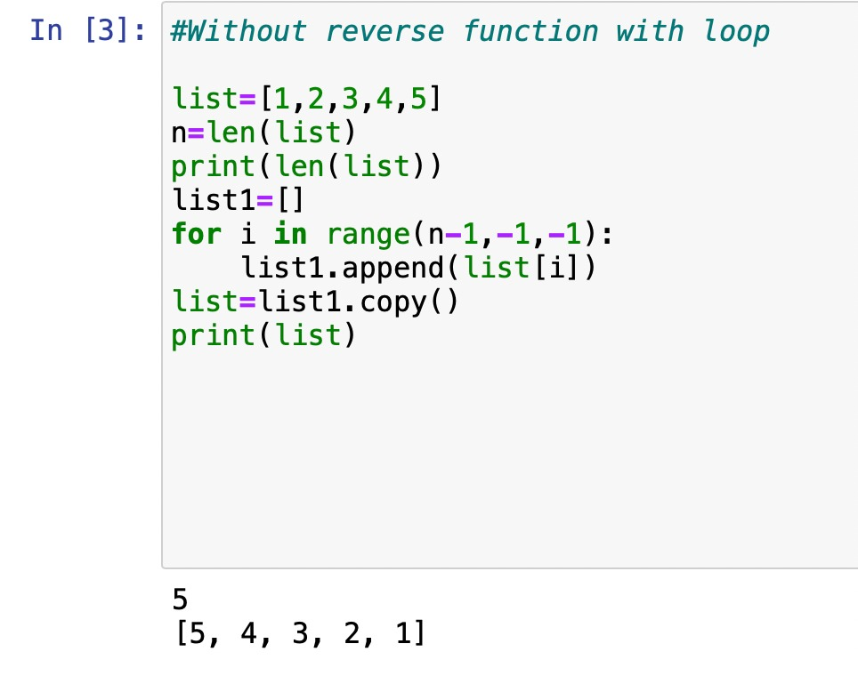

Problem-5:

Problem 5 : Write a python function that takes a string and checks if it’s palindrome or not. Example : “madam” “cat” Result : “Palindrome , not palindrome

Problem -6:

Problem 6 : Write a python program where you will be given a list [5,2,4,3,2,3] and a target value 2 and you have to get the index of the list when the target value appears for the first time. (do it by user inputting the list and target value) For example : here 2 occurs in [1] index for the first time.

Problem-7:

Problem 7: write a python function that takes a list and prints only the positive numbers from

the list. Hint : (Can use the continue keyword)

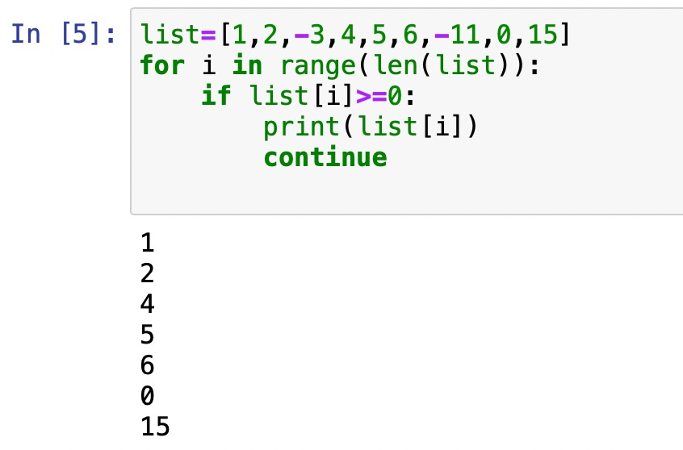

Problem – 8:

Problem 8 : Write a recursive function that accepts a number as its argument and returns the sum of digits or you can use a loop to solve it. Example : 2331 Output : 9

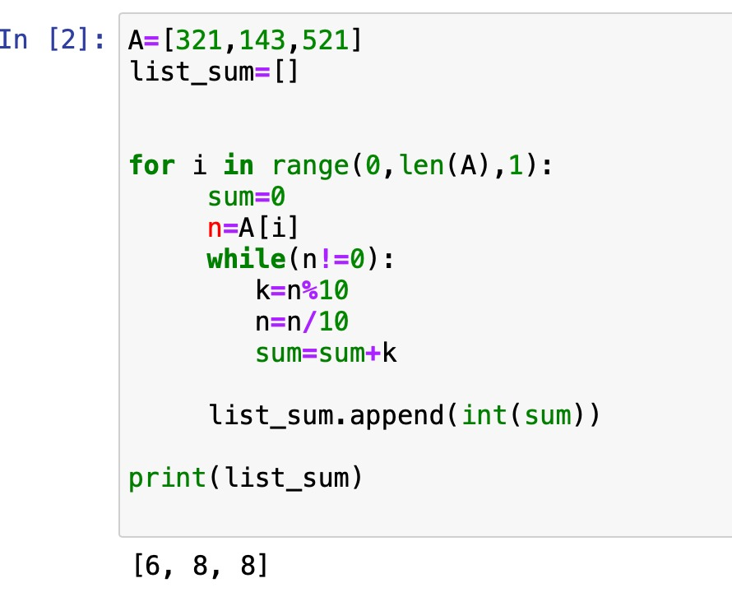

Problem -9:

Problem 9 : Write a recursive function that takes in a list of integers, and returns the sum of only odd numbers inside the list.

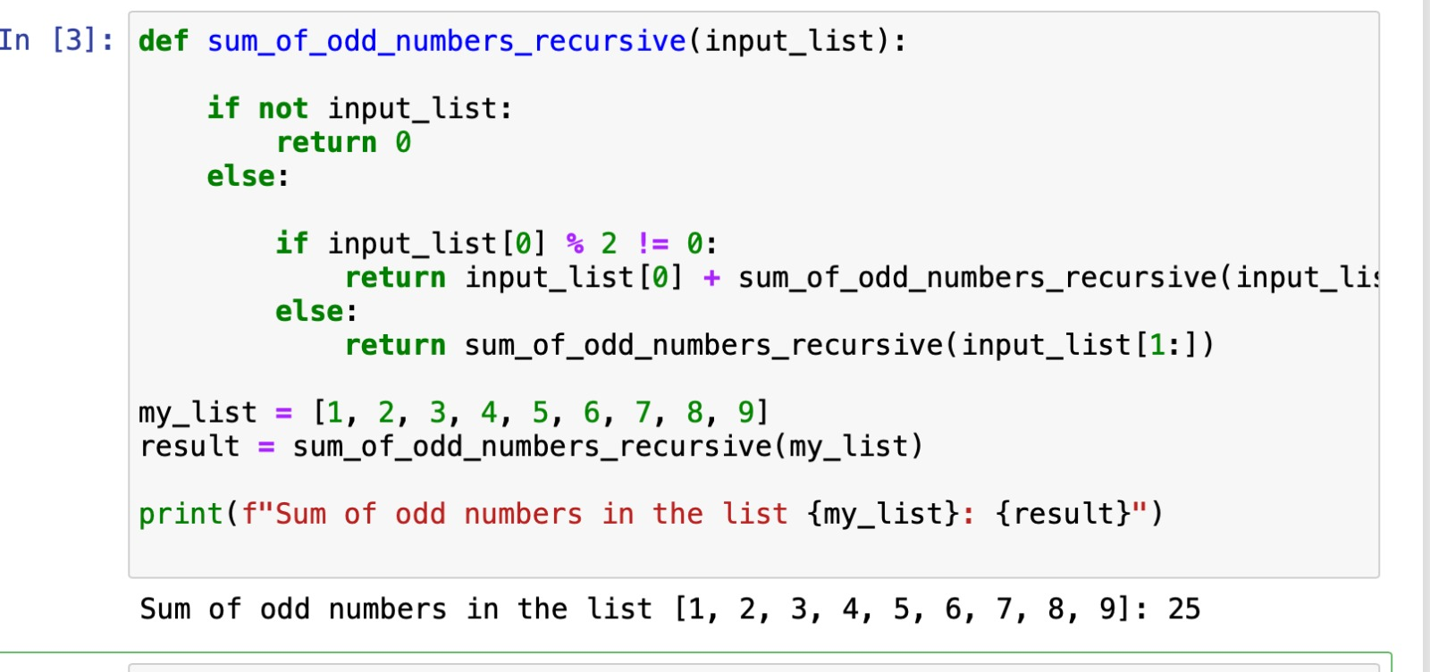

Problem-10:

Problem 10 : Write a python program having two list and compare the values inside the list and make a new list with only the unique values and the new list must be sorted. Example : [1,4,5,6,7] , [2,1,3,4,5] newlist = [2,3,6,7]

